

**Semester One Examination, 2020**

**Question/Answer Booklet**

**MATHEMATICS**

**METHODS**

**ATAR Year 12**

**Section Two:**

**Calculator-assumed**

Student Name: ______________________________________________________

Please circle your teacher’s name

**Teacher: Miss Long Miss Rowden Ms Stone**

**Time allowed for this paper**

Reading time before commencing work: 10 minutes

Working time for paper: 100 minutes

**Materials required/recommended for this paper**

***To be provided by the supervisor***

Number of additional

answer booklets used

(if applicable):

This Question/Answer Booklet

Formula Sheet (retained from Section One)

***To be provided by the candidate***

Standard items: pens (blue/black preferred), pencils (including coloured), sharpener, correction fluid/tape, eraser, ruler, highlighters

Special items: drawing instruments, templates, notes on two unfolded sheets of A4 paper, and up to three calculators approved for use in this examination

**Important note to candidates**

No other items may be taken into the examination room. It is **your** responsibility to ensure that you do not have any unauthorised material. If you have any unauthorised material with you, hand it to the supervisor **before** reading any further.

**Structure of this paper**

|  |  |  |  |  |  |
| --- | --- | --- | --- | --- | --- |
| Section | Number of questions available | Number of questions to be answered | Suggested working time (minutes) | Marks available | Percentage of examination |
| Section One:  Calculator free | 8 | 8 | 50 | 52 | 35 |
| Section Two:  Calculator-assumed | 13 | 13 | 100 | 98 | 65 |
|  |  |  |  | **Total** | 100 |

**Instructions to candidates**

1. The rules for the conduct of the ATAR course examinations are detailed in the *Year 12 Information Handbook 2020*. Sitting this examination implies that you agree to abide by these rules.
2. Write your answers in this Question/Answer booklet.
3. You must be careful to confine your answers to the specific questions asked and to follow any instructions that are specific to a particular question.
4. Supplementary pages for the use planning/continuing your answer to a question have been provided at the end of the Question/Answer booklet. If you use these pages to continue an answer, indicate at the original answer where the answer is continued, i.e. give the page number.
5. Show all your working clearly. Your working should be in sufficient detail to allow your answers to be checked readily and for marks to be awarded for reasoning. Incorrect answers given without supporting reasoning cannot be allocated any marks. For any question or part question worth more than two marks, valid working or justification is required to receive full marks. If you repeat any question, ensure that you cancel the answer you do not wish to have marked.
6. It is recommended that you do not use pencil, except in diagrams.
7. The Formula sheet is not to be handed in with your Question/Answer booklet.

**Section Two: Calculator-assumed 65% (98 Marks)**

This section has thirteen (13) questions. Answer **all** questions. Write your answers in the spaces

provided.

Supplementary pages for the use of planning/continuing your answer to a question have been provided at the end of this Question/Answer booklet. If you use these pages to continue an answer, indicate at the original answer where the answer is continued, i.e. give the page number.

Working time: 100 minutes.

Question 9 (7 marks)

In a sample of $1 325$ university students, $64\%$ said that they never look at their phone while driving.

(a) Show how to use the figures from this sample to construct the $95\%$ confidence interval for the proportion of university students who never look at their phone while driving. (3 marks)

(b) According to a newspaper article, " $70\%$ of university students never look at their phone while driving". Explain whether the interval from (a) supports this claim. (2 marks)

(c) Another source claims that "more than half of university students never look at their phone while driving". Explain whether the interval from (a) supports this claim.

(2 marks)

Question 10 (6 marks)

(a) Function $f$ is defined by $f\left(x\right)=7\log_{4}{(x+16)}-3$ over its natural domain. Determine

(i) the value of the $y$-intercept of the graph of $y=f(x)$. (1 mark)

(ii) the equation of the asymptote of the graph of $y=f(x)$. (1 mark)

(b) Function $g$ is defined by $g\left(x\right)=\log_{n}{x}$ over its natural domain, where $n$ is a constant greater than $1$. The graphs shown below have equations $y=g\left(x\right), y=a-g\left(x\right)$ and $y=g(x+b)$ 
, where $a$ and $b$ are constants. Determine the value of $n, a$ and $b$.

(4 marks)

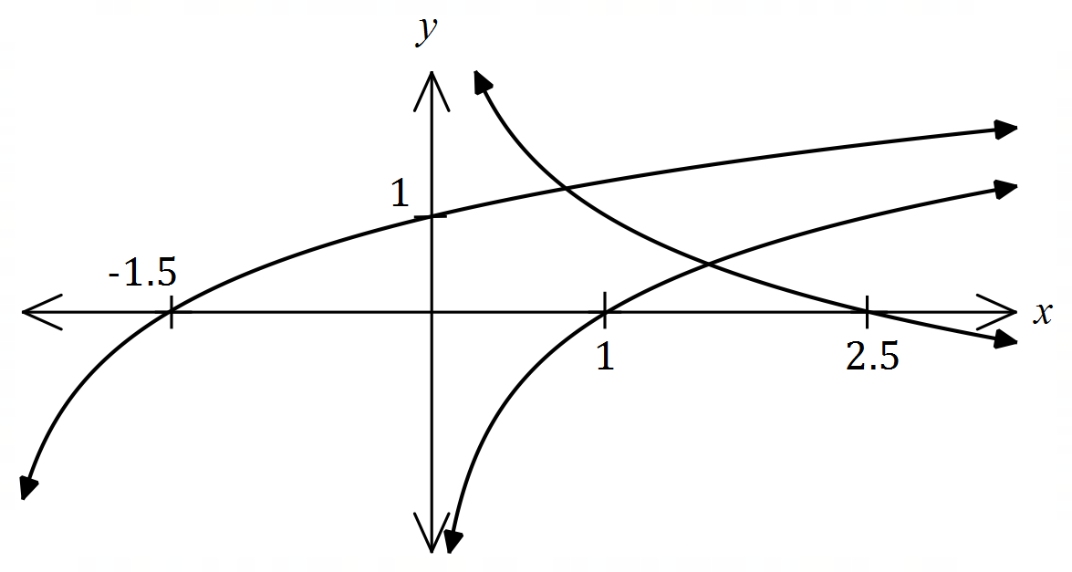

Question 11 (7 marks)

The percentage distribution of the number of cans of soft drink per order placed with a takeaway food company over a long period of time are shown in the following table.

|  |  |  |  |  |  |
| --- | --- | --- | --- | --- | --- |
| Number of cans per order | $$0$$ | $$1$$ | $$2$$ | $$3$$ | $4$ or more |
| Percentage of orders | $$10$$ | $$27$$ | $$39$$ | $$13$$ | $$11$$ |

In the following questions, you may assume that all orders are placed with the company at random and independently.

(a) Determine the probability that the next $4$ orders all include no more than $3$ cans of soft drink. (2 marks)

(b) During a weekday, a total of $180$ orders were placed. Determine the probability that

(i) $130$ of these orders included fewer than $3$ cans of soft drink. (3 marks)

(ii) less than $80$ of these orders included $2$ cans of soft drink. (2 marks)

Question 12 (7 marks)

The heights of girls $H$ in a large study of $3$-year-old children are normally distributed with a mean of $94.5$ cm and a standard deviation of $3.15$ cm.

(a) Determine the probability that a randomly selected girl from the study has a height

(i) greater than 95 cm. (1 mark)

(ii) of at least $90$ cm given that they are shorter than $94.5$ cm. (2 marks)

(b) The shortest $1.5\%$ of girls were classified as unusually short. Determine the greatest height of a girl to be classified as unusually short. (1 mark)

(c) The heights of boys in the study are normally distributed with mean of $96.4$ cm and the shortest $3.5\%$ of boys, with a height less than $90.2$ cm, were classified as unusually short. Determine the standard deviation of the boys' heights. (3 marks)

Question 13 (7 marks)

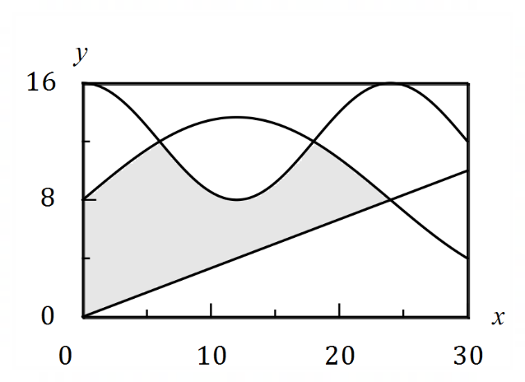The diagram shows a flag design,  
with dimensions in centimetres.

The shaded region is bounded by  
the $y$-axis, $y=f\left(x\right)$, $y=g(x)$  
and $y=h(x)$ where $f(x)=\begin{matrix}x \\ \overline{3}\end{matrix}$ 
  
, $g\left(x\right)=8+4\sqrt{2}\sin\left(\begin{matrix}πx \\ \overline{24}\end{matrix}\right)$ 
  
 and $h\left(x\right)=12+4\cos\left(\begin{matrix}πx \\ \overline{12}\end{matrix}\right)$ 
  
.

(a) Let $A$ be the area of another region on the graph, where $A=\int_{24}^{30}{\underset{ }{\overset{ }{\left[f(x)-g(x)\right]}}}dx$.

(i) Clearly mark the region on the diagram with the letter $A$. (1 mark)

(ii) Determine the value of $A$, rounded to one decimal place. (1 mark)

(b) Using calculus determine the exact area of the shaded region. (5 marks)

Question 14 (6 marks)

A student was set the task of determining the proportion of people in their suburb who use public transport at least once a week.

(a) Briefly discuss the main source of bias in each of the following sampling methods.

(i) The student invites people via social media to respond to their survey. (1 mark)

(ii) The student asks everyone she meets until she has a large enough sample.

(1 mark)

(b) The student noted that $39$ out of all those sampled said they used public transport at least once a week and went on to construct the confidence interval $\left(0.49, 0.81\right).$ Determine the level of confidence of this interval. (4 marks)

Question 15 (8 marks)

A cooling system maintains the temperature $T$ of an integrated circuit between $0.5 °C$ and $1 °C$. At any instant, $T$ is a continuous random variable defined by the probability density function

$$f\left(t\right)=\left\{ \begin{matrix}\frac{a}{t} & 0.5≤t≤1 \\ \overset{ }{0} & \text{elsewhere.}\end{matrix}\right.$$

(a) Determine the exact value of the constant $a$. (2 marks)

(b) Determine a decimal approximation for the probability that a temperature taken at random exceeds $0.85 °C$. (2 marks)

(c) Determine decimal approximations for the mean and standard deviation of the temperature of the integrated circuit. (4 marks)

Question 16 (8 marks)

A charged capacitor discharges through a resistor. Some readings of the deflection $D$ cm of a galvanometer scale in the circuit $t$ seconds after the discharge began are shown on the semilogarithmic graph below.

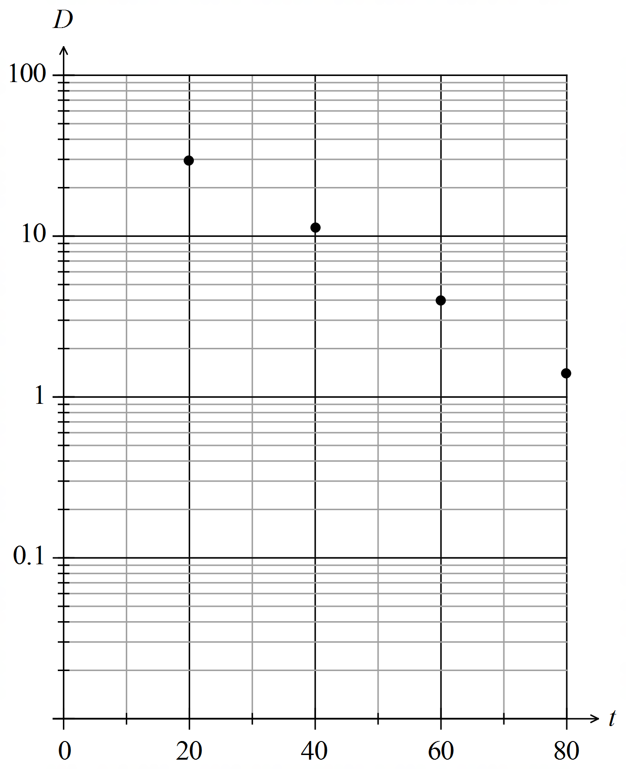

The relationship between the variables is of the form $D=ae^{kt}$, where $a$ and $k$ are constants.

(a) Use the above relationship to obtain an expression for $\ln{D}$ in terms of $a, k$ and $t$ and hence explain why plotting the data using a logarithmic scale on the vertical axis aligns the points in a straight line. (2 marks)

(b) Show how to use the relationship and the galvanometer readings at $t=20$ and

$t=60$ to determine estimates for $a$ and $k$. (4 marks)

(c) Determine

(i) the deflection after $90$ seconds. (1 mark)

(ii) the time for the deflection to reach $1$ mm. (1 mark)

Question 17 (10 marks)

Random samples of $165$ people are taken from a large population. It is known that $8\%$ of the population have blue eyes.

(a) Use a discrete probability distribution to determine the probability that the proportion of people in one sample who have blue eyes is less than $7\%$. (3 marks)

(b) Ten consecutive random samples are taken. Determine the probability that the proportion of those with blue eyes is less than $7\%$ in exactly half of these samples.

(2 marks)

A large number of random samples of $165$ people are taken, the proportion of blue eyed people calculated for each sample and the distribution of these sample proportions analysed.

(c) Describe the continuous probability distribution that these sample proportions approximate, including any parameters. (3 marks)

(d) Describe how two factors affect the closeness of the approximate distribution in (c) to the true distribution of proportions. (2 marks)

Question 18 (8 marks)

A particle moves in a straight line according to the function, , where *t* is in seconds and *x* is the displacement of the particle from a fixed point *O*, in metres.

(a) Determine the velocity function,, for the particle. (1 mark)

(b) Determine the displacement of the particle at the instant it is stationary. (2 marks)

(c) Show that the acceleration of the particle is always positive. (2 marks)

(d) After five seconds, the particle has moved a distance of k metres.

(i) Explain why . (1 mark)

(ii) Calculate *k*. (2 marks)

Question 19 (8 marks)

The cross section of a triangular prism with a volume of cm3 is an equilateral triangle of side length $x$ cm.

(a) Show that the surface area $S$ cm of the prism is given by $S=\begin{matrix}\sqrt{3}x^{2} \\ \overline{ 2 }\end{matrix}+\begin{matrix}216\sqrt{3} \\ \overline{ x }\end{matrix}$.

(4 marks)

(b) Use calculus to determine the minimum surface area of the triangular prism. (4 marks)

Question 20 (8 marks)

The voltage generated by a circuit at time $t$ seconds is given by $V(t)=e^{0.2t}\cos{(3t)}$ for

$0≤t≤4$.

(a) Show that the voltage is initially increasing. (2 marks)

(b) Using a graphical method, or otherwise, determine the voltage at the instant the rate of change of voltage first starts to increase. (3 marks)

(c) Use the increments formula to estimate the change in voltage in the one hundredth of a second after $t=2$. (3 marks)

Question 21 (8 marks)

When a customer plays an online game of chance, a computer randomly picks one letter from those in the word LUCKY, another from those in the word BOIST, and a third from those in the word GAMER. For example, the computer might pick KSR, YBG, and so on. The customer can see the words but does not know the computer's picks and has to guess the letter it has chosen from each word. The random variable $X$ is the number of letters correctly guessed by a customer in one play of the game.

(a) State the distribution of $X$ including its parameters. (1 marks)

(b) Complete the table below to show the probability distribution of $X$. (2 marks)

|  |  |  |  |  |
| --- | --- | --- | --- | --- |
| $$x$$ | $$0$$ | $$1$$ | $$2$$ | $$3$$ |
| $$P(X=x)$$ |  |  |  |  |

Each game costs a player $25$ cents. A player wins a prize of $\$14$ if they guess all three letters correctly, $\$1.40$ if they guess two out of three letters correctly but otherwise wins nothing.

(c) Determine $E(Y)$ and $\operatorname{Var}{(Y)}$, where the random variable $Y$ is the gain, in cents, made by the customer in one play of the game. (4 marks)

(d) If an average of $250$ people from around the world play the game once every $20$ seconds, calculate the gross profit expected by the game owners in any $24$-hour period. (1 mark)

Supplementary page

Question number: _____________________

Supplementary page

Question number: _____________________